Thesis Summary

Shuhao Zhang

February 24, 2020

In the investment community, the time value of money states that money is always more valuable today than in the future. A similar concept of time value of data is getting widely recognized in the data processing community -- insights are derived from processing data, and the value of insights diminishes very fast with time. Due to the increased automation in many domains such as telecommunications, health care, transportation, and retail, numerous data-intensive applications are deployed in real-world use cases. Those applications generally involve continuously low-latency, complex analytics over massive data streams and are often named as streaming applications. Data stream processing system (DSPS) is a software that allows users to efficiently run their streaming applications in a scalable way.

Despite the successes achieved during the last several decades, DSPSs are now facing great challenges when supporting a wide range of emerging applications, which generally require the underlying DSPSs to achieve low end-to-end latency when processing huge volumes of data with complex computation and intensive state access. Witnessing the emergence of modern commodity machines with massively parallel processors, researchers and practitioners and shared-memory multicore architectures an attractive platform for DSPSs. However, fully exploiting the computation power delivered by multicore architectures are still challenging.

In the following, I will summarize my past key research activities during my PhD study surrounding the topic of enhancing modern stream processing systems, which result in four first-authored publications in top-tier conferences in database. Beyond that, I have also first-authored two patents [2, 5] registered in the US based on my past research results, which indicates the large potential of industry and society impact of my research.

Multi-Query Optimization for Complex Event Processing in SAP ESP (ICDE’17)

As a PhD scholar in SAP Innovation Center Singapore from 2014 to 2018, I participated in improving SAP’s stream processing platform, called SAP ESP. The system aims at delivering real-time stream processing and analytics in time-critical applications. In SAP ESP, users can implement their complex event processing tasks, which continuously analysis real-time event streams and quickly identify pre-de ned complex events. I have created MOTTO [4, 5], a multi-query optimizer for complex event processing in SAP ESP as illustrated in Figure 1. MOTTO realizes more sharing opportunities by introducing pattern query decomposition and transformation. Those sharing techniques are also extended to support multiple nested pattern queries and pattern queries with different window constraints. Experiments demonstrate the efficiency of MOTTO with both real-world applications scenarios and sensitivity studies.
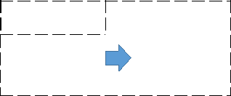

 |  |  |  |  | MOTTO
 | … |  |  |  | Query |  | Query |  | Query_{Opt} |  | SAP ESP
 | Query_{i} |  |  |  | Rewriter |  | Planner |  | Query_{Opt} |  | SAP ESP
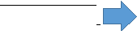


Figure 1: Multi-query optimization workow of MOTTO.

Revisiting the Design of Data Stream Processing Systems on Multi-Core Processors (ICDE’17)

For my Ph.D. dissertation, I was pioneering in discover the gaps between the design of modern stream processing systems and modern hardware architectures. In particular, I summarize [1] three common design aspects of modern DSPSs, including a) pipelined processing with message passing,

- on-demand data parallelism, and c) JVM-based implementation. Then, I conducted detailed pro ling studies with micro benchmark on modern multi-socket multi-core by using Apache Strom and Flink as examples. The results have shown that those designs have underutilized the scale-up architectures in these two key aspects: a) The design of supporting both pipelined and data parallel processing results in a very complex massively parallel execution model in DSP systems, which causes high front-end stalls on a single CPU socket; b) The design of continuous message passing mechanisms between operators severely limits the scalability of DSP systems on multi-socket multi-core architectures. For a concrete example, Figure 2 illustrates that the instruction footprint of both Storm and Flink exceed L1-Instruction cache, and hence leads frequent cache trashing. Based on the pro ling results, I have further proposed two optimizations [2] and demonstrate promising performance improvements.

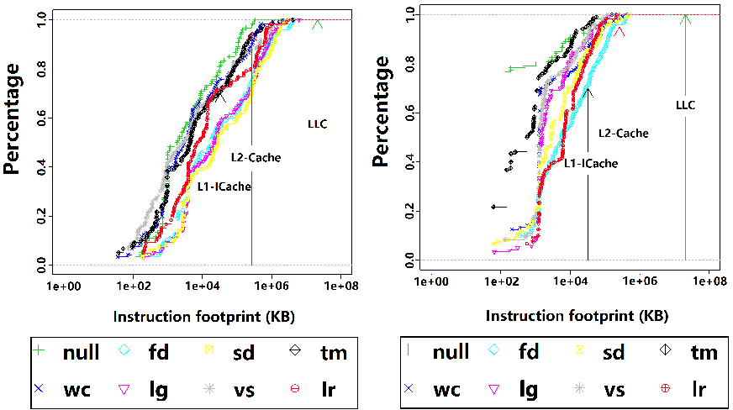

(a) Storm (b) Flink

Figure 2: Instruction footprint between two consecutive invocations of the same function.

BriskStream: Scaling Data Stream Processing on Shared-Memory Multicore Architectures (SIGMOD’19)

My previous pro ling study shows that existing DSPSs underutilized the underlying complex hardware microarchitecture and especially show poor scalability due to the unmanaged resource competition and unaware of NUMA effect. Hence, my subsequent effort spends on a complete revolution in designing next-generation stream processing platform, namely BriskStream [3], specifically optimized for shared memory multicore architectures. To address NUMA effect, I have developed a new streaming execution plan optimization paradigm, namely Relative-Location Aware Scheduling (RLAS). Figure 3 shows the better scalability of BriskStream than existing popular DSPSs on multi-socket servers by taking Linear-Road Benchmark as an example. Unmanaged thread interference and unnecessary remote memory access penalty prevent existing DSPSs from scaling well on the modern multisockets machine. The comprehensive experiments based on two eight-sockets machines con rm that BriskStream significantly outperforms existing DSPSs up to an order of magnitude even without the tedious tuning process. In short, I showed how a DSPS, for the first time, scales stream computation towards a hundred cores under NUMA effect.

Throughput (k event /s)

10000
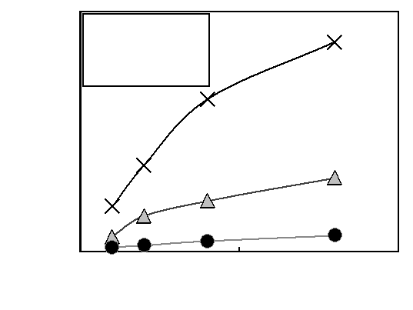
BriskStream

Storm
⁷⁵⁰⁰ Flink

5000

2500

0
0 | 5 | 10
 | Number of CPU sockets

Figure 3: System scalability comparison based on Linear-Road Benchmark.

Towards Concurrent Stateful Stream Processing on Multicore Processors (To appear in ICDE’20)

DSPS with transactional state management relieves users from managing state consistency by themselves, and has recently received attention from both academia and industry community. However, scaling stream processing while providing transactional state management on modern multicore processors is challenging. On the one hand, to achieve both low latency and high throughput, DSPSs can process multiple input events at the same time in order to aggressively exploit parallelism. On the other hand, processing different events concurrently may lead to conflict accesses (reads and writes) to the same application state, hence leading to higher chances of violating transactional state consistency. To make things worse, more than simply guaranteeing the ACID properties preserved in the relational database systems, DSPSs further need to enforce the state access order according to the input event sequence. Witnessing those issues, I have developed TStream [6], a new DSPS that can support highly scalable stream processing with transactional state consistency guarantee on multicores. In order to take advantage of multicore architectures, TStream detaches the state management from the streaming computation logic, and performs its internal state maintenance asynchronously. By eliminating the expensive synchronization primitives, TStream aggressively extracts parallelism opportunities by revealing the operation dependencies at runtime. The initial results show that TStream achieves several times higher throughput on average over existing solutions with similar or even smaller end-to-end processing latency.

References

- Shuhao Zhang, B. He, D. Dahlmeier, A. C. Zhou, and T. Heinze. Revisiting the design of data stream processing systems on multi-core processors. In Data Engineering (ICDE), 2017 IEEE 33rd International Conference on, pages 659-670. IEEE, 2017.

- Shuhao Zhang, B. He, and D. H. R. Dahlmeier. Efficient execution of data stream processing systems on multi-core processors, May 10 2018. US Patent App. 15/348,932.

- Shuhao Zhang, J. He, A. C. Zhou, and B. He. Briskstream: Scaling Data Stream Processing on Multicore Architectures. In Proceedings of the 2019 International Conference on Management of Data, SIGMOD ’19, Amsterdam, Netherlands, 2019. ACM.

- Shuhao Zhang, H. T. Vo, D. Dahlmeier, and B. He. Multi-query optimization for complex event processing in sap esp. In 2017 IEEE 33rd International Conference on Data Engineering (ICDE), pages 1213{ 1224. IEEE, 2017.

- Shuhao Zhang, H. T. Vo, D. H. R. Dahlmeier, and B. He. Multi-query optimizer for complex event processing, Apr. 24 2018. US Patent 9,953,056.

- Shuhao Zhang, Y. Wu, F. Zhang, and B. He. Towards concurrent stateful stream processing on multicore processors. ICDE ’20.

